**Procedure**

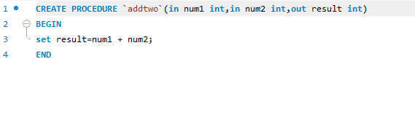

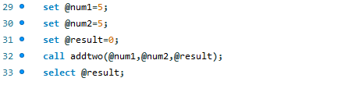

**Trigger**

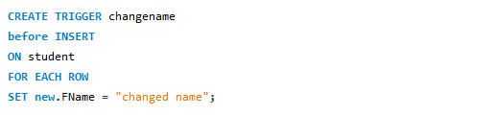

Show triggers;

Drop trigger triggername;